**ĐẠI HỌC QUỐC GIA THÀNH PHỐ HỒ CHÍ MINH**

**TRƯỜNG ĐẠI HỌC**

**CÔNG NGHỆ THÔNG TIN**

NHẬP MÔN CÔNG NGHÊ PHẦN MỀM

**CS4273.N12.CTTT**

**Giáo viên hướng dẫn: Vũ Tuấn Hải**

Thành viên:

Lê Trí Khoa 20521466

Nguyễn Hữu Thiên 20521951

Lâm Lê Phúc Huy 20521388

Nguyễn Phi Hùng 20521425

Table of Contents

**1. Overview3**

1.1. Abstract3

1.2. Actors survey3

1.3. Organizational survey 3

1.4. Phenomenon survey 4

1.5. Requirement list 4

**2. Use Case model7**

2.1. Actors List7

2.2. Use Case Diagram7

2.3. Use Case List8

2.4. Use Case Description9

**3. Sequence diagrams12**

**4. Database23**

4.1. Database design23

4.2. Database description23

**5. UI Prototype27**

5.1. Online Link 27

5.2. Design List 27

5.3. Design 27

**6. Conclusion34**

5.3. Result34

5.3. Future plan 35

5.3. Work table35

PROJECT: MANGA TRACKER

# Overview

## Abstract

In the year 2022, when information technology is developing and advancing with rocket speed bringing all kinds of benefits and advantages to our modern society. Simply with our smart phone and Internet access, we can get access to all sorts of entertainment available only within a few touches. And especially with the Japanese anime culture which has spread across the world for the past two decades, manga has also become one of the most important entertainment industries in the world and the amount of people who read manga daily has reached an astonishing figure. Furthermore, we are living in an amazing digital age, which means we can get unlimited access to the enormous number of manga online easily with just our phone, and we have don’t have to buy a physical one which may be very expensive because of the shipping fee from Japan. With the vast number of manga available to us at any time, it’s something hard to navigate through all of them just to find a good manga with your genre or from your favorite author. To overcome some of the difficulties and make it easier for us to read manga, we could use a manga management software to:

- Manage manga that we are reading/ have finished reading/ our favorite manga.

- Get recommendation of manga that are trending around the world.

- Share your opinion and comments about a manga with other people.

- Create and customize an account to fit to your personal preferences.

## Actors survey

A manga management software system usually consists of two main parts: user (reader) and admin (page manager).

* 1. Organizational survey

Manga management include sorting manga into gerne and author’s name, searching manga bases on genre and author’s name, managing accounts, sorting manga of users bases on which they are reading, have finished reading, their personal favorite and showing them the trending manga as well as the statistic total manga they have read.

* + 1. Manga searching procedure

- Step 1: User views the information in the main page.

- Step 2: User views the list manga sorted by genre or author’s name using the searching tool.

* + 1. Sign up procedure

- Step 1: User accesses the Signup page.

- Step 2: User enters username, password and email.

- Step 3: User presses Signup, if it’s successful, user will be moved to the Login page.

* + 1. Log in procedure

- Step 1: User accesses the Login page.

- Step 2: User enters username and password.

- Step 3: User presses Login, if it’s successful, user will be moved to the main page.

* + 1. Log out procedure

- Step 1: User accesses the account management page.

- Step 2: User presses Logout button and will be moved to the main page.

* + 1. Account management procedure

- Admins can manage user’s account by deleting inactive accounts, deleting negative comments, promoting active accounts in the page.

- Users can edit their accounts such as changing avatar, putting their favorite quote in the account home page, viewing the statistic of their manga reading process.

* + 1. Manga management procedure

- Users can manga their process of reading manga by sorting them into 3 categories: in process of reading, finished reading and personal favorite.

- Admins and users can also recommend current trending manga on the main page.

* + 1. Changing password procedure

- Step 1: User accesses the Login page.

- Step 2: User clicks on “Forget password ?” button, system will send an confirmation email to user.

- Step 3: User clicks on the confirmation link in the mail, after that user will be moved to the Changing password page.

- Step 4: User enters new password, if it’s successful, user will be notified and moved to the main page.

* + 1. View manga info procedure

User click on the manga he/she wants to read to view information about the gerne, the summary, the author’s name and his/her process of reading.

* 1. Phenomenon survey
     1. IT status

With user, usually from the age of 10 going up, have simple or basic knowledge of using smart phone, know how read manga online and create an account. With admin, usually from the age of 24 going up, have advanced knowledge in programming, creating and managing a system. Therefore, IT level and knowledge of user and admin is sufficient to access and read manga online.

* + 1. Hardware status

Almost everyone in nowadays society has access to Internet and a smart phone with 2 – 8 GB RAM.

* 1. Requirement list

|  |  |  |  |  |
| --- | --- | --- | --- | --- |
| Ordinal | Requirement | Form | Regulation | Note |
| 1 | Create new track | F.1 | R.1 |  | |
| 2 | Manga information | F.2 |  |  | |
| 3 | Manga track list | F.3 |  |  | |
| 4 | Manga searching and filtering | F.4 | R.4 |  | |

* + 1. F.1 and R.1

|  |  |  |
| --- | --- | --- |
| F.1 | Create Track | |
| Manga Name: | | Scores: |
| Reading chapter: | | Start Date: |
|  | | End Date: |

R.1 Start Date can’t be a NULL value but End Date can, because of some reason like that Manga is still on going

Ex:

|  |  |  |
| --- | --- | --- |
| F.1 | Create Track | |
| Manga Name: One-Piece | | Scores: 9 |
| Reading chapter:122 | | Start Date: 12/11/2010 |
|  | | End Date: |

* + 1. F.2

|  |  |  |
| --- | --- | --- |
| F.2 | Manga information | |
| Manga Name: | | Chapter: |
| Genres: | | Status: |
| Author: | | Publish year: |

Ex:

|  |  |  |
| --- | --- | --- |
| F.2 | Manga information | |
| Manga Name: One-Piece | | Chapter: 1024 |
| Genres: Shounen | | Volumes: 104 |
| Author: Eiichiro Oda | | Status: On-going |
|  | | Publish year: 1997 |

* + 1. F.3

|  |  |  |  |  |  |  |  |
| --- | --- | --- | --- | --- | --- | --- | --- |
| F.3 | Manga Track List | | | | | | |
| Ordinal | Manga Name | Genres | Scores | Reading chapter | Start date | End date | Publish year |
| 1 |  |  |  |  |  |  |  |
| 2 |  |  |  |  |  |  |  |

* + 1. F.4 and R.4

|  |  |  |  |  |  |
| --- | --- | --- | --- | --- | --- |
| F.3 | Manga List | | | | |
| Ordinal | Manga Name | Genres | Author | Status | Publish year |
| 1 |  |  |  |  |  |
| 2 |  |  |  |  |  |

R.4 Genres will be divided into tags for filtering

1. Use Case model
   1. Actors List

|  |  |  |
| --- | --- | --- |
| Num. | Actor Name | Meaning, Note |
| 1 | User | Read and search for manga, sign up, log in, log out and edit account. |
| 2 | Admin | Add new manga and account, delete old/corrupt manga link and inactive account. |

* 1. Use Case Diagram
     1. Use Case for user

* + 1. Use Case for Admin

* 1. Use Case List

|  |  |  |
| --- | --- | --- |
| Num | Use Case Name | Meaning, Note |
| 1 | Sign up | Create a new account into the system. |
| 2 | Log in | Login your account into the system. |
| 3 | Log out | Logout your account into the system. |
| 4 | Search | Search for manga based on genre/author. |
| 5 | Forget password | Allow user to create new password if old password is forgotten. |
| 6 | Account Management | Allow user to edit account, change password and view statistic. |
| 7 | Manga Management | User can view manga info and view which manga user is reading/finished reading/’s favorite. |
| 8 | View Statistic | Display the number of manga user is reading/finished reading/’s favorite. |
| 9 | Trending | Display the current trending manga for user. |
| 10 | View manga Info | User can view the description, the summary, the genre and the author of a manga which user is reading/finished reading/’s favorite or trending. |

* 1. Use Case Description
     1. Sign up Use Case

|  |  |  |
| --- | --- | --- |
| **Description** | User creates a new account into the system. | |
| **Participating Actor** | User. | |
| **Flow of Events** | User actions | System actions |
| 1. User clicks Sign up button. | 2. Display Sign up form. |
| 3. Enter username, email and password into the form. | 4. Check the validation of username and password, send out verification email. |
| 5. Click Verify button in the email. | 6. Notify user sign up successfully. |
|  | 7. Return to main page. |
| **Alternative Flows** | 4.a User entered invalid username/password/email.  4.b Request user to reenter the form. | |
| **Exit Conditions** | User entered valid username/password and verified email, or user hasn’t created an account before using the same email. | |

* + 1. Log in Use Case

|  |  |  |
| --- | --- | --- |
| **Description** | User logs into created account. | |
| **Participating Actor** | User. | |
| **Flow of Events** | User actions. | System actions. |
| 1. User clicks Login button. | 2. Display Login form. |
| 3. User enters username and password. | 4. Check the validation of username and password. |
|  | 5. Notify user login in successfully. |
|  | 6. Return to main page. |
| **Alternative Flows** | 4.a User entered invalid username or password.  4.b Request user to reenter valid username or password. | |
| **Entry Conditions** | User has created an account before. | |
| **Exit Conditions** | User logged in account successfully. | |

* + 1. Log out Use Case

|  |  |  |
| --- | --- | --- |
| **Description** | User logs out of already logged in account. | |
| **Participating Actor** | User. | |
| **Flow of Events** | User actions. | System actions. |
| 1. User clicks Log out button. | 2. Display Log out form. |
|  | 3. Notify user log out successfully |
|  | 4. Return to main page. |
| **Alternative Flows** |  | |
| **Entry Conditions** | User has already logged in the account. | |
| **Exit Conditions** |  | |

* + 1. Search Use Case

|  |  |  |
| --- | --- | --- |
| **Description** | User searches for manga based on genre/author. | |
| **Participating Actor** | User. | |
| **Flow of Events** | User actions. | System actions. |
|  | 1. User choose a genre in the list or enters an author’s name. | 2. Display manga that have the chosen genre, or manga written by entered author’s name. |
| **Alternative Flows** |  | |
| **Entry Conditions** |  | |
| **Exit Conditions** |  | |

* + 1. Forget password Use Case

|  |  |  |
| --- | --- | --- |
| **Description** | User creates a new password in case the old password is forgotten. | |
| **Participating Actor** | User. | |
| **Flow of Events** | User actions. | System actions |
|  | 1. User clicks Forget password button. | 2. System sends out an email to user to verify. |
| 3. User clicks on the link in the email to confirm. | 4. Display a change password form. |
| 5. User enters new password. | 6. System check if the new password is the same as the old password. |
|  | 7. Notify user change password successfully. |
| **Alternative Flows** | 6.a The new password is the same as old password.  6.b Notify user the new password is the same as the old password and ask user to reenter a different password. | |
| **Entry Conditions** | User must click on the confirmation link in the mail sent by system. | |
| **Exit Conditions** | User clicks cancel button.  User enters a new and different password for the old one. | |

* + 1. Account management Use Case

|  |  |  |
| --- | --- | --- |
| **Description** | Allow user to edit account, change password and view statistic. | |
| **Participating Actor** | User. | |
| **Flow of Events** | User actions. | System actions. |
|  | 1. User clicks the account avatar on the main page. | 2. Display an information page of user’s account. |
| **Alternative Flows** |  | |
| **Entry Conditions** | User has already logged in the account. | |
| **Exit Conditions** |  | |

* + 1. Manga management Use Case

|  |  |  |
| --- | --- | --- |
| **Description** | User can view manga info and view which manga user is reading/finished reading/’s favorite. | |
| **Participating Actor** | User. | |
| **Flow of Events** | User actions. | System action. |
|  | 1. User clicks on Manga management button. | 2. Display manga info and view which manga user is reading/finished reading/’s favorite. |
| **Alternative Flows** | 2.a User hasn’t read a manga on this page before  2.b Notify user that they haven’t read a mange on this page before and display an empty page. | |
| **Entry Conditions** | User has already logged in the account. | |
| **Exit Conditions** |  | |

* + 1. View statistic Use Case

|  |  |  |
| --- | --- | --- |
| **Description** | Display the number of manga user is reading/finished reading/’s favorite. | |
| **Participating Actor** | User. | |
| **Flow of Events** | User action. | System action. |
|  | 1. User click on View statistic button in User’s account page. | 2. Display the number of manga user is reading/finished reading/’s favorite in a table. |
| **Alternative Flows** |  | |
| **Entry Conditions** | User has already logged in the account. | |
| **Exit Conditions** |  | |

* + 1. Trending Use Case

|  |  |  |
| --- | --- | --- |
| **Description** | Display the current trending manga for user. | |
| **Participating Actor** | User. | |
| **Flow of Events** | User action. | System action. |
|  | 1. User enter the main page. | 2. Display the current trending manga. |
| **Alternative Flows** |  | |
| **Entry Conditions** |  | |
| **Exit Conditions** |  | |

* + 1. View manga info Use Case

|  |  |  |
| --- | --- | --- |
| **Description** | User can view the description, the summary, the genre and the author of a manga which user is reading/finished reading/’s favorite or trending. | |
| **Participating Actor** | User. | |
| **Flow of Events** | User actions. | System action. |
|  | 1. User clicks on a manga. | 2. Display the description, the summary, the genre and the author of the manga. |
| **Alternative Flows** |  | |
| **Entry Conditions** |  | |
| **Exit Conditions** |  | |

1. Sequence diagrams
   1. Sign Up

* 1. Log In

* 1. Log Out

* 1. Search

* 1. Forget password

* 1. Account Management

* 1. Manga Management

* 1. View Statistic

* 1. Trending

* 1. View manga infoDiagram

     Description automatically generated
  2. Change manga status

1. Database
   1. Database design

* 1. Database description

|  |  |  |  |  |
| --- | --- | --- | --- | --- |
| 1. Ordinal | Field name | Data type | Constraint | Description |
| 1 | ID | Int(10000) | PrimaryKey | User ID |
| 2 | RoleID | Int(10000) | ForeignKey | References to table Role |
| 2 | Name | Nvarchar(1000) | Not Null | Name of user |
| 3 | Password | Nvarchar(1000) | Not Null | Password |

**Table users_login**

**Table user_INFO**

|  |  |  |  |  |
| --- | --- | --- | --- | --- |
| Ordinal | Field name | Data type | Constraint | Description |
| 1 | Id | Int(10000) | PrimaryKey | User Profile Id |
| 2 | Login_id | Int(10000) | ForeignKey | References to table Login |
| 2 | Name | Nvarchar(1000) | Not Null | Name of user |
| 3 | Avatar | Object |  | Profile picture |

**Table Manga**

|  |  |  |  |  |
| --- | --- | --- | --- | --- |
| Ordinal | Field name | Data type | Constraint | Description |
| 1 | id | Int(10000) | PrimaryKey | Manga ID |
| 2 | name | Nvarchar(1000) | Not Null | Name of user |
| 4 | genres | Nvarchar(1000) | Not Null | Genres of manga |
| 4 | status | Nvarchar(1000) | Not Null | Manga Status |
| 5 | author | Nvarchar(1000) | Not Null | Author of manga |
| 6 | publish_year | Datetime | Not Null | The year that a manga publish |
| 7 | create_at | Datetime | Not Null | The date manga adding into data |
| 8 | thumbnail | Object |  | Manga cover imange |

**Table track**

|  |  |  |  |  |
| --- | --- | --- | --- | --- |
| Ordinal | Field name | Data type | Constraint | Description |
| 1 | id | Int(10000) | Primary Key | Track ID |
| 2 | manga_id | Nvarchar(1000) | Foreign Key | References to table Manga |
| 3 | manga_name | Nvarchar(1000) | Not Null | Name of Manga |
| 4 | score | Int(10) |  | Score review of user |
| 5 | reading chapter | Int(10000) | Not Null | Number of chapter which was read |
| 6 | start_date | Datetime | Not Null | The date starting reading |
| 7 | end_date | Datetime |  | The date completing reading |

**Table track _details**

|  |  |  |  |  |
| --- | --- | --- | --- | --- |
| Ordinal | Field name | Data type | Constraint | Description |
| 1 | id | Int(10000) | Primary Key | Track detaild ID |
| 2 | track_id | Nvarchar(1000) | Foreign Key | References to table Track |
| 3 | manga_id | Nvarchar(1000) | Foreign Key | References to table Manga |
| 4 | user_id | Int(10000) | Foreign Key | References to table user_INFO |
| 5 | manga_name | Nvarchar(1000) | Not Null | Name of Manga |
| 6 | genres | Nvarchar(1000) | Foreign Key | References to table genres_tag |
| 7 | reading chapter | Int(10000) | Not Null | Number of chapter which was read |
| 8 | Score | Int(10) |  | Score review of user |
| 6 | start_date | Datetime | Not Null | The date starting reading |
| 7 | end_date | Datetime |  | The date completing reading |

**Table genres_tag**

|  |  |  |  |  |
| --- | --- | --- | --- | --- |
| Ordinal | Field name | Data type | Constraint | Description |
| 1 | genres_id | Int(10000) | Primary Key | Genres Id |
| 2 | Genres | Nvarchar(1000) | Not Null | Genres of manga |

**Table mangastatus**

|  |  |  |  |  |
| --- | --- | --- | --- | --- |
| Ordinal | Field name | Data type | Constraint | Description |
| 1 | status_id | Int(10000) | Primary Key | Status Id |
| 2 | manga_id | Nvarchar(1000) | Foreign Key | References to table Manga |
| 3 | status | Nvarchar(1000) | Not Null | Status of manga |

**Table filter**

|  |  |  |  |  |
| --- | --- | --- | --- | --- |
| Ordinal | Field name | Data type | Constraint | Description |
| 1 | manga_id | Nvarchar(1000) | Foreign Key | References to table Manga |
| 2 | status | Nvarchar(1000) | Foreign Key | References to table mangastatus |
| 3 | genres | Nvarchar(1000) | Foreign Key | References to table genres_tag |

**Table search**

|  |  |  |  |  |
| --- | --- | --- | --- | --- |
| Ordinal | Field name | Data type | Constraint | Description |
| 1 | manga_id | Nvarchar(1000) | Foreign Key | References to table Manga |
| 2 | Name | Nvarchar(1000) |  | Input name form user |

**Table trending**

|  |  |  |  |  |
| --- | --- | --- | --- | --- |
| Ordinal | Field name | Data type | Constraint | Description |
| 1 | manga_id | Nvarchar(1000) | Foreign Key | References to table Manga |
| 2 | Name | Nvarchar(1000) |  | Name of manga |

**Table role**

|  |  |  |  |  |
| --- | --- | --- | --- | --- |
| Ordinal | Field name | Data type | Constraint | Description |
| 1 | id | int(10000) | Primary Key | RoleID |
| 2 | Name | Nvarchar(1000) |  | RoleName |

1. UI Prototype
   1. Online Link

<https://www.figma.com/file/YcCl0B32pICxjI1EjZZCez/CNPM-G3?node-id=136%3A106>

* 1. Design List

|  |  |
| --- | --- |
| **Design** | **Description** |
| Main menu | An introduction about the site and its features |
| Login | Login feature |
| Sign up | Sign up feature |
| Search | Search title, genre or authors |
| Profile | Show personal profile of users, theirs stats and activities |
| Trending | Show top 100 manga |
| Manga Information | Example of a manga information |

* 1. Design
     1. Main menu

* + 1. Login

* + 1. Sign up

* + 1. Search

* + 1. Profile

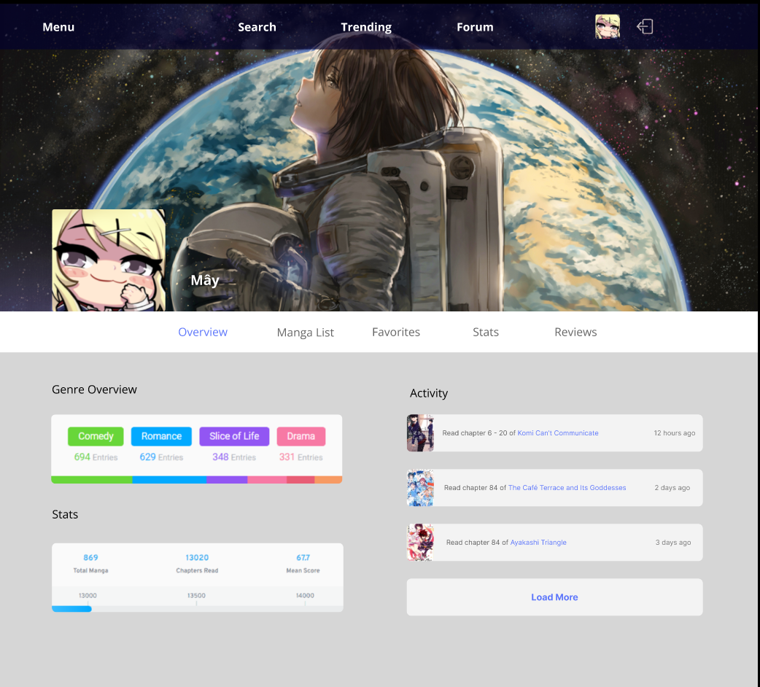

* + 1. Trending

* + 1. Manga Information

1. Conclusion
   1. Result
      1. Advantages

- Accessible by different devices, ranging from smart phone to PC, with minimum hardware requirements.

- Development cost is almost non-existent, the only minor development cost is developers’ time.

- System is fairly stable without any buffer or error.

- Easy for new users to use or create new accounts.

- Easy for users to navigate and find the manga they want.

- Give users sufficient information about a manga to help them decide whether the manga is worth spending their precious time on.

* + 1. Disadvantages

- The user’s account has limited user interface customization capabilities.

- Some old manga’s may be corrupted and need to be replaced.

- Can not handle a huge number of access.

* 1. Future plan

- User’s account interface will be more customable in the future.

- System will handle more number of access.

- Make a mobile version

- Make a social platform

* 1. Work table

|  |  |
| --- | --- |
| **Name - ID** | **Task** |
| Lê Trí Khoa - 20521466 | Sequence Diagrams, designer, making report |
| Nguyễn Hữu Thiên - 20521951 | Introduction, Conclusion, Use case |
| Lâm Lê Phúc Huy - 20521388 | Lead designer |
| Nguyễn Phi Hùng - 20521425 | Database design, requirement |